**SUBJECT – PRACTICAL DATA ANALYTICS**

**CAPSTONE PROJECT MILESTONE 1**

**TEAM INFINITY**

**TEAM MEMBERS**

**RISHITA GAUTAM- PGD20239666**

**PUSHAP DIGRA- PGD202343534**

**VINAYAK KAUL- PGD202340093**

**MOHIT SINGH- PGD202348279**

**SAHIL THAKUR- PGD202348306**

**ADITYA GUPTA- PGD202349524**

**AMAN KUMAR SINGH- PGD202349380**

**NIKHIL KUMAR- PGD202350099**

* **FIVE IDEAS THAT OUR TEAM BRAINSTORMED**

1. Lost and Found
2. Wastage of food
3. Nokia’s Windows phone
4. Sell AI data
5. Holographic Projector

**Idea that the team has picked- *“NOKIA’S WINDOWS PHONE”***

* **PROBLEM STATEMENT**

**Context:**

Windows phone was a mobile operating system that was developed by Microsoft, which was launched in 2010.

In 2011, Nokia and Microsoft partnered with each other to produce Windows phone devices (Nokia Lumia).

While doing this project, we are assuming that Windows phone devices (Nokia Lumia) are launched by Nokia in present context and what steps we can take to maximize sales of devices that Nokia failed to do in 2011.

***Problem statement:***

*Nokia’s Windows phone failed to gain a large market share due to lack of innovation, high- quality devices and various other factors. This project aims to examine those factors and provide strategies to prevent downfall of Nokia.*

**Major issues in the product:**

1. ***User Interface***

UI was not user friendly rather it was complex

1. ***Limited Applications***

According to a report by *Appfigures*, Windows phone store has almost 7,00,000 apps as compared to 3.5 million apps and 2.2 million apps in apple and google store respectively.

1. ***Slow Software***

Performance of the phones were very slow due to lack of timely updates

1. ***Limited Telecom Carrier support***

Windows phone *Nokia Lumia 900* was only available on AT&T (telecommunication company in US).

**Objectives:**

1. To develop and launch technologically advanced windows phone devices with user friendly interface.
2. To increase global market share of Nokia and re-establish itself as competitive player in the smartphone segment.
3. Restore the brand image of Nokia that was disappeared due to various factors
4. Execute effective marketing strategies to raise awareness and interest in windows phone devices.

* **DATASET**
* Sales of Windows phone peaked in 2013, when 33.3 million units were sold. Later on, sales started declining and by 2016, only 2.2 million windows phones were sold.

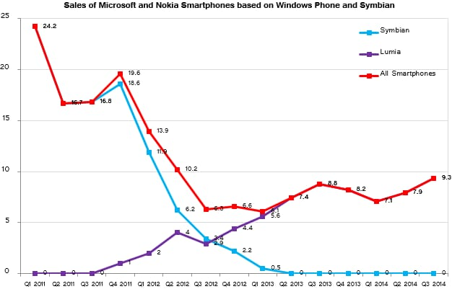

* Below is the table of market share before and after launching windows phone in key regions:

|  |  |  |
| --- | --- | --- |
| **Regions** | **Market share before launch** | **Market share after launch** |
| North America | 33.5% | 4.5% |
| Europe | 38.9% | 13.7% |
| Asia Pacific | 33.5% | 21.2% |
| Latin America | 34.9% | 26.3% |
| Middle East and Africa | 31.5% | 23.8% |

Below are some customer reviews:

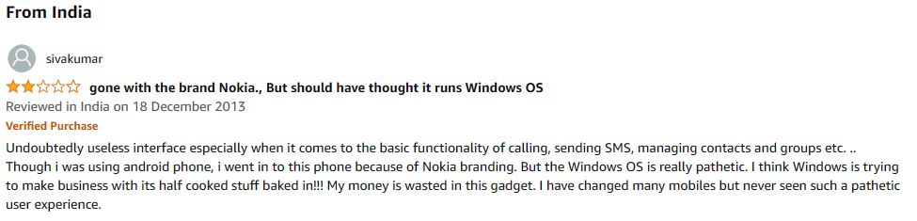

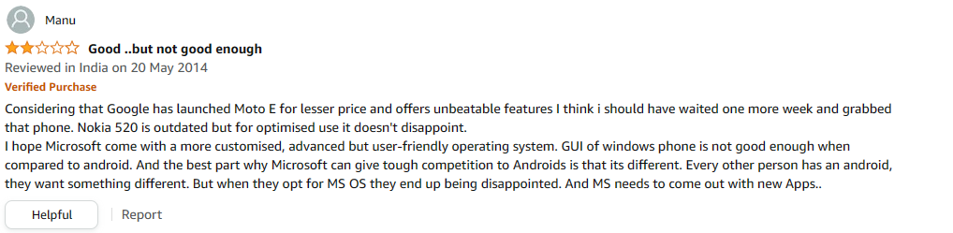

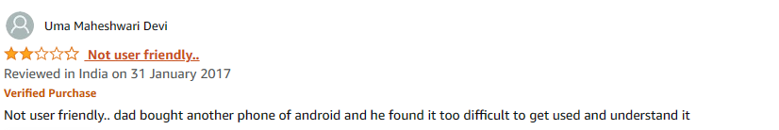

* **STRATEGIES TO RESOLVE THE PROBLEM**

1. **Improve the user interface-**

* Improve the app drawer by making it easier to navigate and launch apps
* By making it more customizable by giving users the control over how it looks
* Reduce the amount of time it takes for apps and features to load
* Maintaining a consistent user experience by ensuring third party apps and services integrate seamlessly with UI

1. **Provide more applications-**

* Increase the number of applications
* Attract more developers to create more apps for the platform

1. **Improve performance-**

* By providing timely updates
* Use more powerful hardware and more memory to allow devices to run more efficiently
* Provide more security features by introducing fingerprint unlock options and face recognition
* Improve security by conducting regular scans
* Keep security checks on third party apps

1. **Increase carrier partnerships-**

* Make exclusive deals with telecom service providers, because they play a major role in buying decision of customers
* Emphasize on things like IOT, 5G services, VoWiFi because the current market is moving in this direction

1. **Improve marketing strategy**

* Utilize Nokia's old reputation to build trust with consumers
* Utilize social media to influence and attract the customers
* Make product consumer centric.
* Keeping the price affordable (Rs. 20000- Rs.27000)

1. **Focus on customer feedback**

* Keep taking feedbacks from customers and keep updating the features according to customer’s needs
* **VALUES IT WILL BRING TO THE SOCIETY**
* Creating more jobs in smartphone industry and giving more employment opportunities
* It will lead to increase in competition in smartphones market ultimately resulting in innovative features and services to customers
* Increase in sales of the windows phone can contribute in economic growth
* Accessibility to a wider range of customers, as Nokia was before known for its affordability and durability
* **VISUALISATION THAT OUR TEAM IS PLANNING TO USE**

1. **Product comparison chart-**

To compare the features of Nokia’s Windows smartphone with other smartphones. To make a comparison between what services our product offers which the competitors don’t

1. **Pie chart-**

To show market share of different smartphone operating systems, with the focus on windows phone market share

1. **Line chart-**

To show the projected growth of sales over the coming years

1. **Infographics-**

To show the evolution of Windows phone operating system

* **USER PERSONA AND USER STORIES**

**USER 1**

**NAME-** RISHITA GAUTAM

**PLACE-** HIMACHAL PRADESH

**AGE**- 23

**GENDER**- FEMALE

**EDUCATION**- BACHELOR’S IN SCIENCE (MATHEMATICS)

**EXPERIENCE**- 6 Months experience as Customer Service Representative in RELIANCE JIO

**USER ROLE- CUSTOMER SERVICE REPRESENTSTIVE**

**ROLES & RESPONSIBILITIES-**

1. First point of contact for customers
2. Helps in building and maintaining good customer relationships
3. Collect and convene the customer feedback to the managing team
4. Listen to customer’s problems and complaints and provide solutions
5. Promote new product and services to customers

**GOALS-**

1. To promote Nokia’s windows phone to customers
2. To gather feedback from the customers about the new phone
3. To resolve any issues faced by customers

**PAIN POINTS-**

1. Sometimes it’s hard to deal with demanding customers
2. Following the latest improvements in the products and services

**USER STORY-**

As a Customer Service Representative for Nokia, I need to quickly access information regarding the new Windows phone of Nokia so that I can provide the customers with accurate and helpful information.

**USER 2**

**NAME-** MOHIT SINGH

**PLACE-** SHIMLA (HP)

**AGE-**22

**GENDER-** MALE

**EDUCATIN-** B.COM

**USER ROLE- OPERATION MANAGER**

**Roles and Responsibilities-**

1. Overseeing the production of goods and services
2. performing quality control and assurance on production.
3. Helping organization processes remain legally complaint.
4. preparing and overseeing budgets

**GOALS-**

1. Increase the organization’s productivity
2. Increase profits while reducing costs.
3. The production and delivery of products or services are suit on consumer’s needs

**PAIN POINTS-**

1. Concerned over productivity
2. Need to improve quality of products or services
3. Worried about customer satisfaction

**USER STORY-**

As an operation manager of Nokia. Nokia fall from the top of the smart phone. The company failed to keep up with the changing trends in smartphone design and continued to produce devices that looked outdated and lacked the aesthetic appeal of its competitors.

**USER 3**

**NAME**- Vinayak Kaul

**PLACE**- Jammu & Kashmir

**AGE**- 22

**GENDER**- Male

**EDUCATION**- BBA

**EXPERIENCE**- Intern at Diala bank for 3 months

**USER ROLE - PRODUCT MANAGER**

**ROLES AND RESPONSIBILTY-**

1. Develop and refine the product strategy based on market research, customer feedback, and business goals.
2. Act as the voice of the customer and advocate for their needs and preferences within the organization.
3. Effectively communicate the product roadmap, strategy, and updates to internal teams and stakeholders.
4. Conduct market research to understand customer needs, competitive landscape, and industry trends.
5. Oversee the entire product development lifecycle, from concept to launch.

**GOALS-**

1. Ensure the successful development, launch, and ongoing success of the product.
2. Meet or exceed customer expectations and satisfaction.
3. Contribute to the growth of the company by delivering successful and revenue-generating products.
4. Increase or maintain the company's market share by offering competitive and valuable products.

**PAIN POINTS-**

1. Changes in the market, customer preferences, or competitive landscape can create uncertainty.
2. Balancing the expectations of various stakeholders, including executives, customers, and internal teams, can be a delicate task.
3. Dealing with technical complexities, especially if the Product Manager lacks a technical background, can be a pain point.

**USER STORY-**

As a Product Manager, I want to gather comprehensive user feedback on the latest product and focus on the objective of enhancing a specific aspect of the Windows Phone ecosystem, the messaging app, by combining user feedback, design collaboration, and development execution.

**USER 4**

**NAME -** Aman Kumar Singh

**PLACE - Bihar**

**AGE-** 24

**GENDER-** MALE

**EDUCTION-** B.COM

**USER ROLE - SALES AND MARKETING MANAGER**

**ROLES & RESPONSIBILITIES-**

1. Sales strategy - creating sales plan, and identifying target markets and customers segments.
2. Marketing strategy - Develop marketing plan to create brand awareness, generate leads, market research, and support sales effort, etc.
3. Customer relationship - Build and maintain strong relationship with customer and customer satisfaction.

**GOALS-**

1. Revenue Growth - The primary goal of a sales and marketing manager is to increase revenue sales and marketing initiatives that attract new customers.
2. Customer Acquisition - Expand the customer base by identifying and targeting new market area and city
3. Budget Efficiency

**PAIN POINTS-**

1. Not enough training
2. Low lead quality
3. To many meeting

**USER STORY-**

Aa a Sales and Marketing Manager I want to contribute to the Company's revenue growth by developing and implementing strategies to attract and retain customers. This role involves a combination of sales strategy, marketing planning, team management and data analysis.

**USER 5**

**NAME**- Aditya Gupta

**PLACE**- Himachal Pradesh

**AGE**- 20

**EDUCATION**- Bachelors in Commerce

**EXPERIENCE**- 6 Months Work Experience as an Accountant in a school

**USER ROLE– Finance Manager**

**ROLES AND RESPONSIBILTIES-**

1. Develop and implement financial strategies like budgeting, forecasting, and financial modeling to achieve the company's objectives.
2. Prepare and present accurate and timely financial reports to senior management, stakeholders, and regulatory authorities.
3. Identify and assess financial risks, develop risk mitigation strategies, and manage the company's financial exposure.
4. Cash Management: Monitor and manage the company's cash flow to ensure that it has enough liquidity to meet its operational needs and obligations.

**GOALS-**

1. Profit maximization
2. Efficient Resource Allocation
3. Cost control
4. Financial stability

**PAIN POINTS-**

1. Deal with unforeseen costs
2. Be flexible and adjust the budget as needed by the project
3. Enhance data quality and accuracy
4. Navigating compliance changes

**USER STORY-**

As a Finance Manager of Nokia, I need to be quick in decision making. I need to be good in analysis of market numbers and shares.

**USER 6**

**NAME-** PUSHAP DIGRA

**PLACE-** HIMACHAL PRADESH

**AGE-** 23

**GENDER-** MALE

**EDUCATION-** Bachelor’s in Science & Computer Applications

**USER ROLE- BUSINESS DEVELOPMENT MANAGER**

**ROLES & RESPONSIBILTIES-**

1. Develop and implement a business strategy to achieve company’s growth goals.
2. Identify new business opportunities and work on them
3. Represent the company at industry events and trade shows
4. Negotiate and close deals

**GOALS-**

1. Increase company’s sales and revenue
2. Expand the company’s market share
3. Develop new business opportunities
4. Increase brand awareness and recognition

**USER STORY-**

As a business development manager, I want to be able to quicky and easily identify new business opportunities so that I can develop and pursue them effectively

**USER 7**

**NAME-** Sahil thakur

**PLACE-** HIMACHAL PRADESH

**AGE- 21**

**GENDER- MALE**

**EDUCATION-** Bachelor’s in Commerce

**USER ROLE- Supply Chain Manager**

**ROLES & RESPONSIBILITIES-**

1. Collaborate with sales and marketing teams to ensure demand forecasts are met.
2. Build and maintain strong relationships with suppliers, negotiate contracts, and monitor supplier performance in terms of quality and cost.
3. Manage the procurement process, including sourcing materials and components, supplier selection, and cost negotiation.
4. Define key performance indicators (KPIs) and metrics to evaluate supply chain performance and track progress toward goals

**GOALS-**

1. Facilitate effective communication with team members, suppliers, and other stakeholders
2. Use mobile tools to communicate with suppliers, share information, and collaborate on procurement decisions, such as negotiating terms and pricing.

**PAIN POINTS-**

1. Windows Phone had a smaller app ecosystem compared to Android and iOS.
2. Security and data protection are critical in supply chain management.

**USER STORY-**

I want to ensure the timely delivery of critical electronic components for our mobile phone production line to avoid production delays and meet customer demand effectively.

**USER 8**

**NAME-** Nikhil Kumar

**AGE-** 20

**GENDER-** Male

**EDUCATION-** BSC (Mathematics)

**USER- RESEARCH AND DEVELOPMENT MANAGER**

**GOALS AND RESPONSIBILITIES-**

1. **Product Development:** To oversees the development of new products and features, ensuring that they meet the highest quality standards.
2. **Market Analysis:** Closely monitor market trends, competitive intelligence, and customer feedback to identify opportunities for product improvement and innovation.
3. **Budget Oversight:** Manage project budgets and ensure cost-effective use of resources.
4. **Risk Management:** Identify potential risks and develop mitigation strategies to minimize project disruptions.
5. **Resource Management:** Allocate resources, including personnel, budget, and equipment, to ensure successful project execution.

**PAIN POINTS-**

1. Balancing the need for innovation with budget limitations is a constant challenge.
2. Keeping up with the rapid pace of technological change in the telecommunications industry
3. Managing teams and projects across different time zones and cultures can be challenging.
4. Balancing the need for innovation with budget limitations is a constant challenge.

**USER STORY-**

As a Research and Development Project Manager at Nokia, I want to lead a cross-functional team to develop cutting-edge 6G technology solutions so that Nokia can maintain its position as a global technology leader and contribute to shaping the future of telecommunications.

* **WIREFRAME**

<https://drive.google.com/file/d/18lhEVqGPxOR5yASOr7yrYMKHDoDqBXmE/view?usp=drive_link>

Click on the above link to have a look of our device

